# Results

*Risk to confuse a younger with an older species*

For the combination of strictly bifurcating speciation and all extinction scenarios, selecting the phylogenetically youngest and oldest species never resulted in a case where the presumed older species has been in fact the younger of the two species according to their simulated age (Figure 9). Thus, there is no risk of committing a qualitative error when comparing species at the extremes of the age range of a time-calibrated phylogeny. In contrast, for budding speciation, even under no extinction, in 2.2% of all cases the phylogenetically oldest species had a true age youngerthan the phylogenetically youngest species.This rate of committing a qualitative error reached 7.5% and 12.2% for intermediate and high extinction, respectively. When we compare the ages of two random species instead of the phylogenetically youngest and oldest species, the error rate for confusing the older with the younger one generally increased. While there is no such risk under bifurcating speciation with no extinction, the error rate increased 6% and 8%, respectively, for intermediate and high extinction (Figure 10). Under budding speciation , irrespectively of the extinction level, the younger species was confused with the older in more than 25% of all cases.

*Quantifying uncertainty in species age under budding speciation*  
The coverage of true ages by the 95% confidence interval obtained with our geometric age function is considerably high, with 94% in a low, 90% for an intermediate, and 76% for a high extinction scenario (Figure 13). However, the width of the confidence intervals is large, reaching often from almost the root of the phylogeny until the phylogenetic age of the species.

Imprint of extinction risk on phylogenetic ages  
Phylogenetic age showed a completely correct estimation (i.e. 5 of 5 conservation status reflected by the phylogenetic age of the species) in 75% of the trees in a low, 69% in an intermediate, and 56% in a high extinction scenario (Figure 14)  
When acknowledging partial correct estimation (3 or more conservation status estimated corrected), the phylogenetic age showed the same pattern with 97% in a low, 94% in an intermediate, and 91% in a high extinction scenario. Moreover, the mean probable age slightly improved with 99% in a low, 97% in an intermediate, and 87% in a high extinction scenario.

# Discussion

I think the discussion needs a better structure. I suggest:

* Short summary of the key results. This is especially crucial if you have 14 result + supplementary figures. This should end with the message that speciation mode and high extinction have the highest impact on age errors (if I understand the results correctly)
* Why does speciation mode matters?
* Why is high extinction introducing large errors? (Crucial to mention that most likely extinction is high in the real world)
* Are eco-evolutionary analyses affected by erroneous species ages?
* What can be done to mitigate this effect?

If you agree, I can move the sections below but doing this now would probably cause a bit of chaos.

Our study shows that extinction rates and speciation modes greatly influence the mismatch between true and phylogenetic age. Moreover, the error patterns are different regarding the combination of both processes. As we expected, a phylogeny whose taxonomy was derived from a bifurcating speciation process presents no or low mismatch between true and phylogenetic age due to the bifurcating node structure of phylogenies and the way phylogenetic age is estimated (Meier and Willmann 2000). Our study has also shown that under budding speciation shows an high error in phylogenetic age under no extinction that increases linearly with extinction(Figure 4). Likewise, anagenetic speciation, combined with budding or bifurcating speciation, resulted in high errors. The anagenetic error is not affected by extinction rates, suggesting that if a clade experiences a certain degree of anagenesis, it should be discouraged to estimate ages from phylogenies. The geometric function did not improve the accuracy regarding the true age estimation. Its large confidence intervals and the high coverage, suggest that there is little signal of the species age in a phylogeny under budding speciation. Since the coverage is also relatively high with high extinction, the main source of uncertainty is indeed the mode of speciation

For bifurcating speciation, the mean error between true and phylogenetic age was low, even in scenarios of high extinction. This is because taking the most recent ancestral node as phylogenetic age results in sister species to be identical in age, the same as implied by bifurcating speciation. Due to only introducing bias by extinction, there was a low risk of confusing the oldest with the youngest species. This means that for this speciation mode, the inferences made from the relationship between phylogenetic age and eco-evolutionary variables indeed capture the signal of the true age.

For budding speciation, there is a high mismatch between ages, even in no-extinction scenarios; however, the overall error does not increase considerably with increasing extinction rates. Half of the phylogenetic age estimations in no-extinction scenarios always underestimate the true age, while when extinction rates increase, overestimation appears and rises until balancing with underestimation at high extinction scenarios. This pattern happens due to the phylogenetic estimation assumption of considering sister species as coeval, which, in no extinction scenario, only correctly estimates the youngest species of any bifurcation. Moreover, when extinction rates increase, the youngest species of a clade evolving through bifurcation speciation can be wrongly taken as phylogenetically old (i.e. having a long terminal branch) if all ancestral species to that branch are extinct. Due to these misinterpretation patterns, the qualitative error is high and increases considerably (four-fold) with extinction rates in the extreme example of the oldest vs. youngest species. Thus, for clades diversifying predominantly through budding speciation, the phylogenetic age is not equal to the true age for half of the species, and some of these mismatches would be extreme regarding the true age.

Given the sometimes large error when equating phylogenetic age with the age of the species, the question is whether this affects the inferences made from the relationship between a clade’s evolutionary history and eco-evolutionary variables like range sizes or XXX. If phylogenetic ages still capture the overall tendency the true ages related to one or more variables, it could be argued that phylogenetic age is useful to infer relationships between species longevity and eco-evolutionary variables. Most authors using phylogenetic age for their research acknowledge the challenges, and have proposed approaches to account for them by combining phylogenetic, biogeographic,and ecological information (Swenson 2019). The same strategy (utilizing the stem age) was applied for associating taxon age to range size and extinction risk in plants (Tanentzap et al. 2020). Additionally, Sonne et al. (2022) determined young and old Andean hummingbirds by generating 1000 trees and listing the species that fell into the first and fourth branch length quartile, respectively, and then used a sensitivity analysis to evaluate the consequences of different species composition in their results (Fjeldså, Bowie, and Rahbek 2012). Nevertheless, neither strategy acknowledges the real problems of age uncertainty: the unknown extinction rates and speciation modes of phylogenies. The extinction signal analysis makes this point clear because it showed that, even with the strong signal we assigned on purpose to the true ages, the number of incorrect inferences is considerable high among extinction scenarios.

Our results point out the errors associated with budding and bifurcating speciation; however, how do we know which is the predominant speciation mode of a clade to contemplate a likely percentage error in the phylogenetic age? Anacker and Strauss (2014) proposed, for example, that budding speciation leaves some signatures in sister species: they should have overlapping or adjacent ranges, their range sizes should be asymmetrical, and specific ecological traits should differ between them. These signatures are associated with sympatric and peripatric speciation (Barraclough, Vogler, and Harvey 1998). In this sense, bifurcating speciation can be associated with allopatric speciation and the signatures it leaves in the range of sister species: ranges should not be overlapping or adjacent, range sizes should not necessarily be asymmetrical, and ecological traits should not necessarily differ between them (Barraclough and Vogler 2000; Fitzpatrick and Turelli 2006). Thus, assessing a clade’s spatial dynamics before performing species age analyses could give us insights into the speciation modes and an approximate error of phylogenetic ages. In the case of the errors associated with different extinction scenarios, combining phylogenetic information with fossil data is recommended, although the fossil record is scarce in some groups (Rabosky 2010; Silvestro, Salamin, and Schnitzler 2014; Brée, Condamine, and Guinot 2022; López-Martı́nez et al. 2023).

Using simulations, we showed the problems in estimating species age from phylogenetic trees and quantify the error in estimations under different scenarios. The challenges of using phylogenetic age as a proxy for species longevity are not merely methodological. Time-calibrated phylogenetic trees of extant species do not contain information on the error sources, namely speciation modes and extinction rates. Thus, the phylogenetic age provides some information about true age, but it is a weak proxy to measure evolutionary history. Assessing the speciation modes with the methods suggested here or others and estimate extinction rates by combining paleontological and neontological data, might help to estimate the ages percentage error. Approaches combining phylogenies, biogeography (to inform speciation modes), diversification (extinction rates), and traits might provided a more comprehensive understanding on the relationship of species longetivity and eco-evolutionary processes.

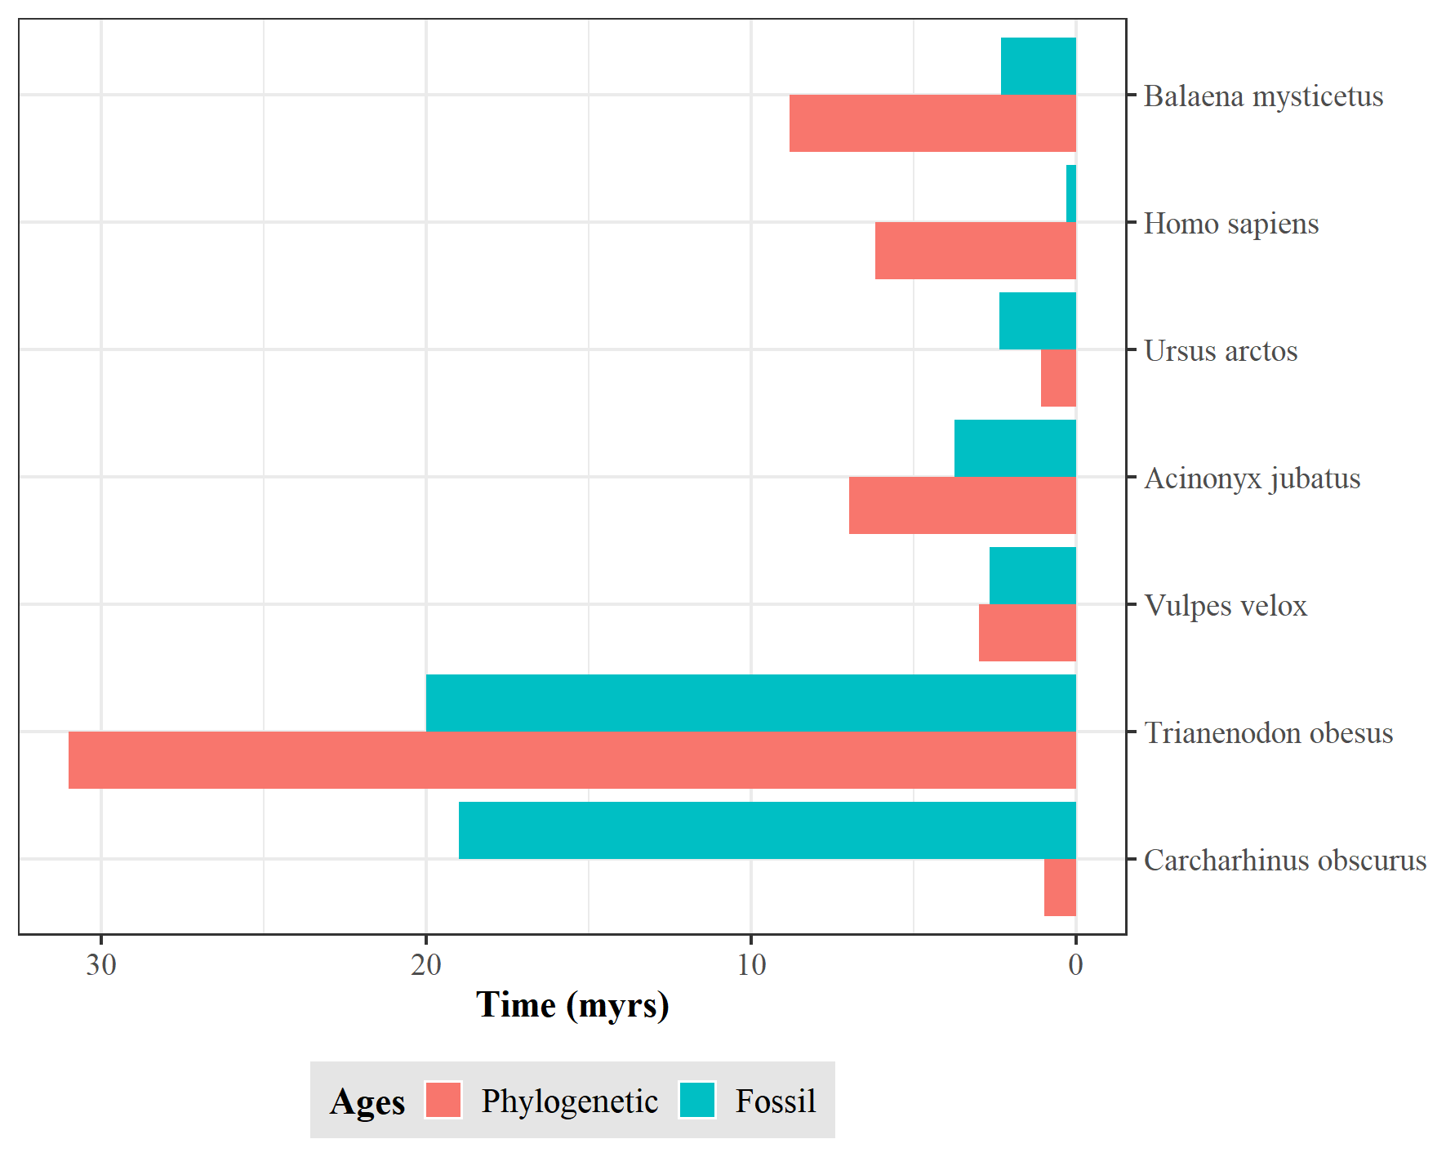

1. Discrepancy between species ages. Estimations based on the first appearance in the fossil record and the length of the terminal branch in a time-calibrated phylogeny. Data obtained from…Comparison between the age estimated by the phylogenetic data and the fossil record for seven different species

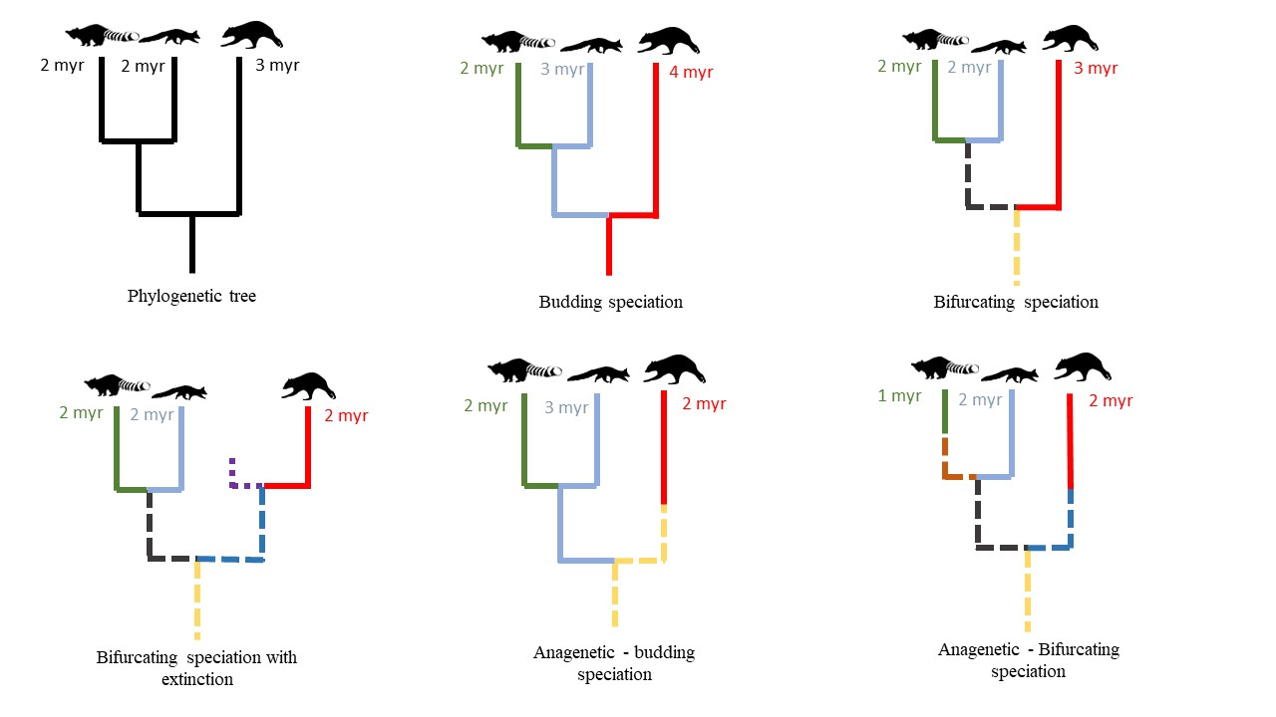

2. Impact of speciation mode and extinction on species age. For the same hypothetical, time-calibrated phylogeny of extant species, the continuation of the same color indicates the same species, solid lines represent extant, and dashed lines extinct species under different speciation modes and extinction scenarios. Numbers display the resulting age of the respective species.

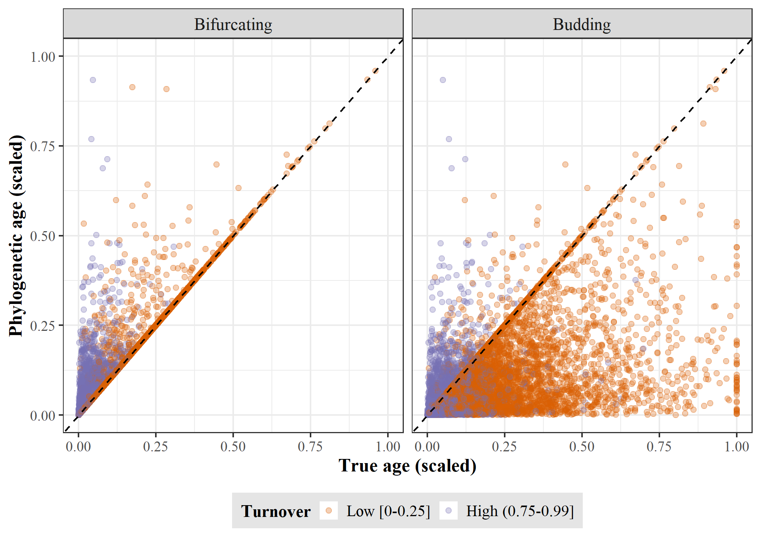

3. True age versus phylogenetic age at low and high turnover. for bifurcating and budding speciation.

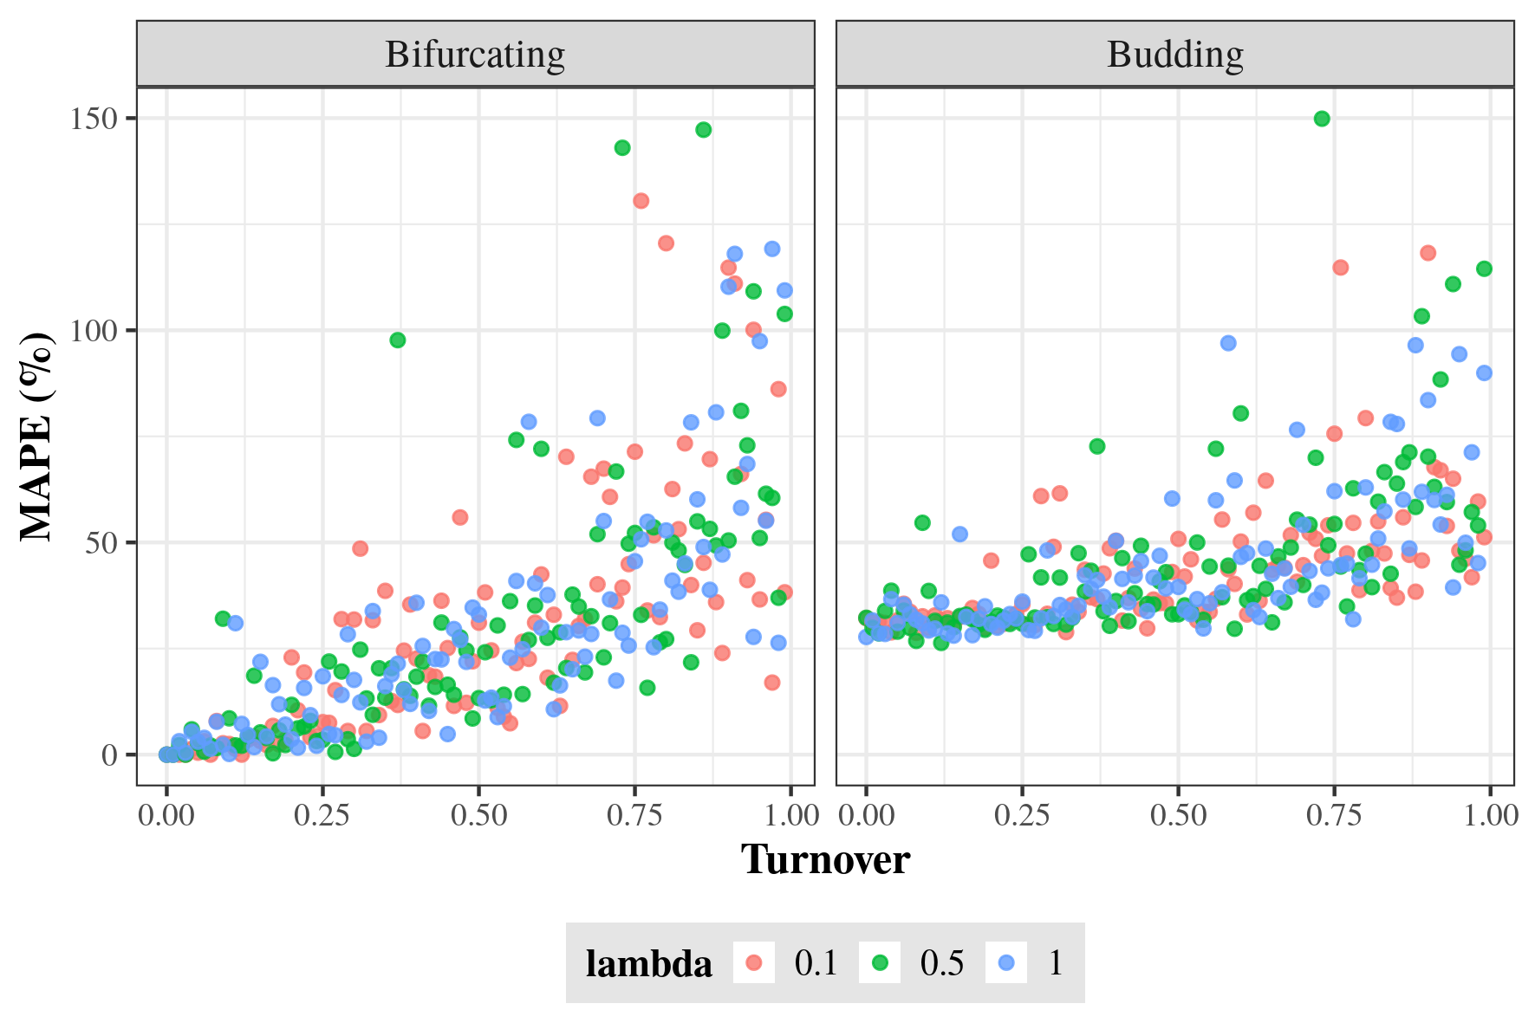

4. Error in equating phylogenetic age with speciation age. Error was quantified as mean absolute percentage error (MAPE) between the true ages of 100 species simulated under (a) bifurcating and (b) budding speciation and their phylogenetic ages after pruning extinct species. Each dot represents one replicate of the 300 simulations for each speciation mode using different rates of speciation and turnover.

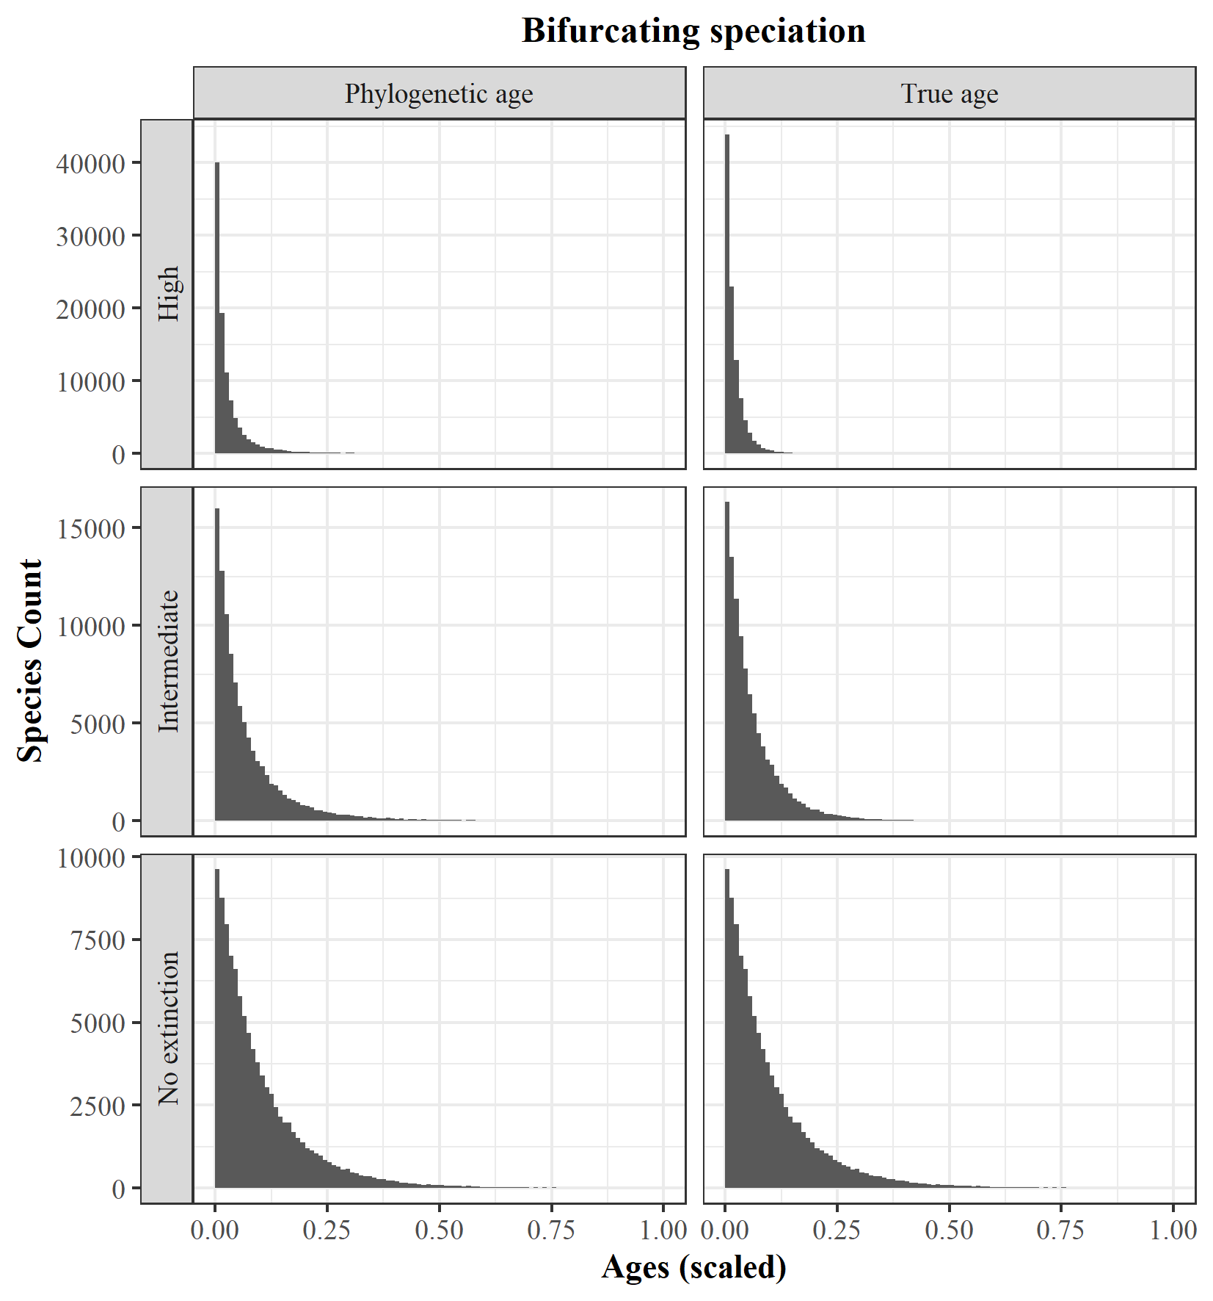

5. Comparison between the True age vs. Phylogenetic age (scaled) distributions in different extinction scenarios (No extinction, Intermediate, and High); for bifurcating speciation

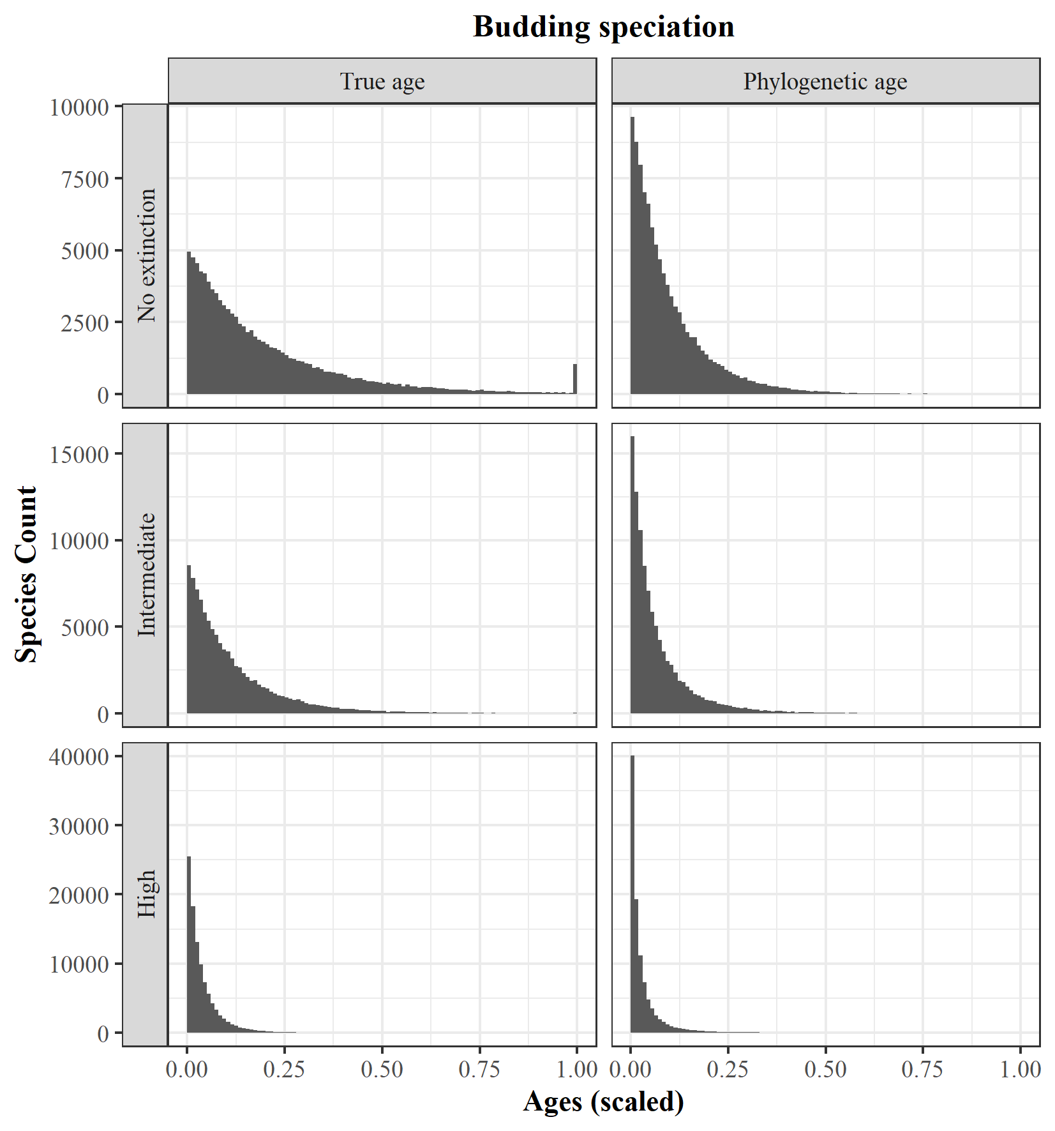

6. Comparison between the True age vs. Phylogenetic age (scaled) distributions in different extinction scenarios (No extinction, Intermediate, and High); for budding speciation

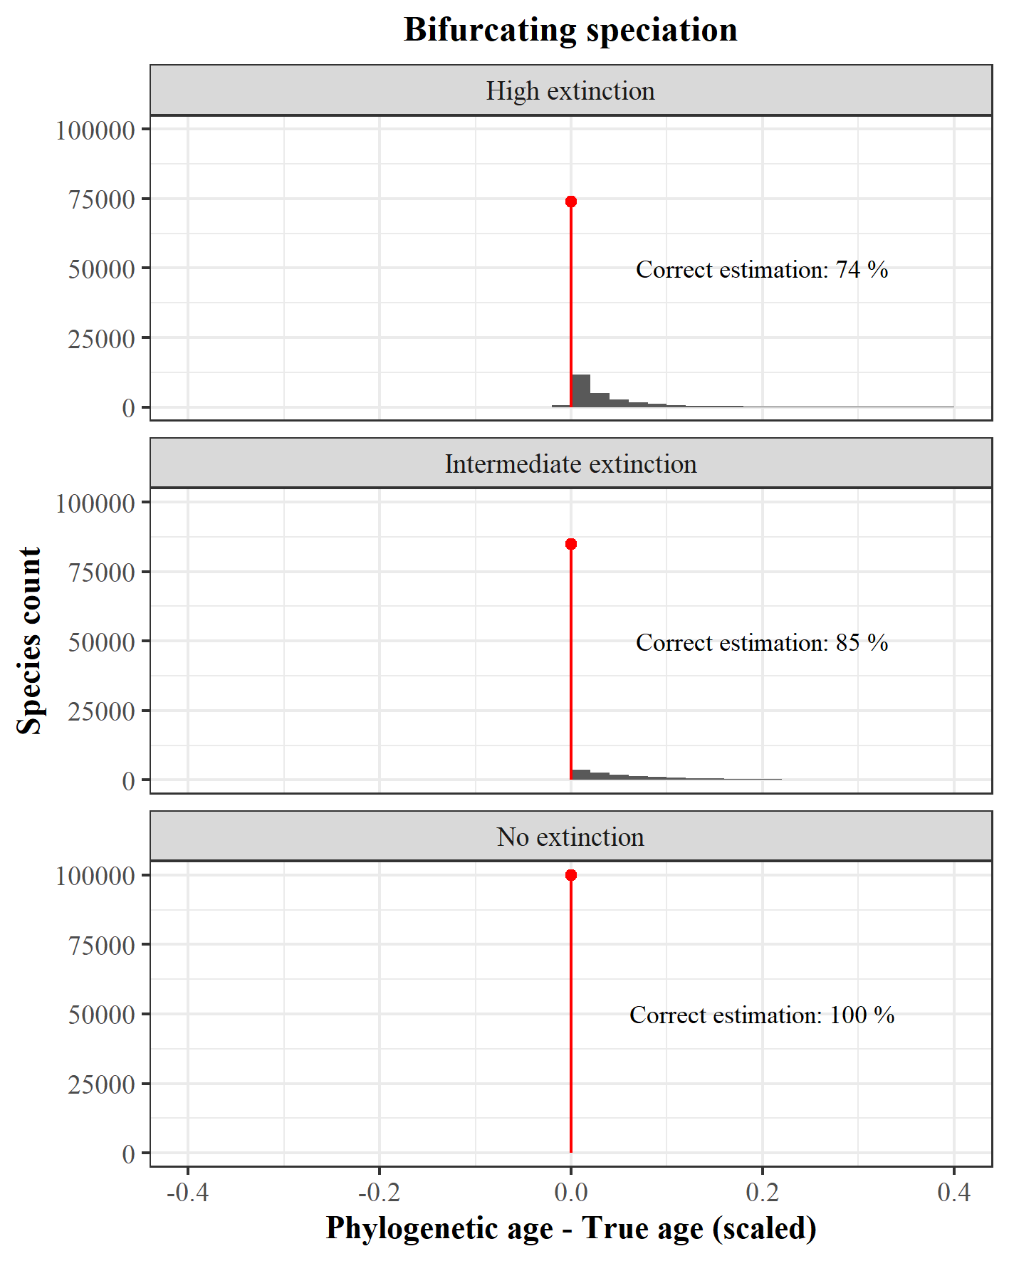

7. Phylogenetic - True age (scaled) in different extinction scenarios (No extinction, Intermediate, and High); for bifurcating speciation

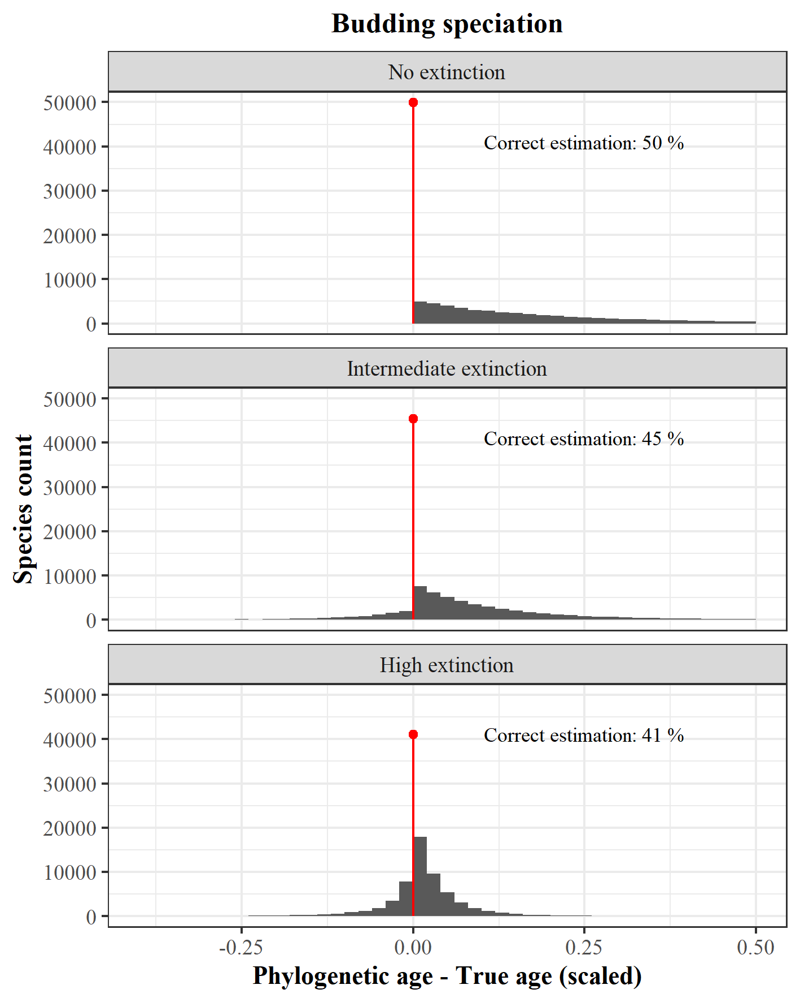

8. Phylogenetic - True age (scaled) in different extinction scenarios (No extinction, Intermediate, and High); for budding speciation

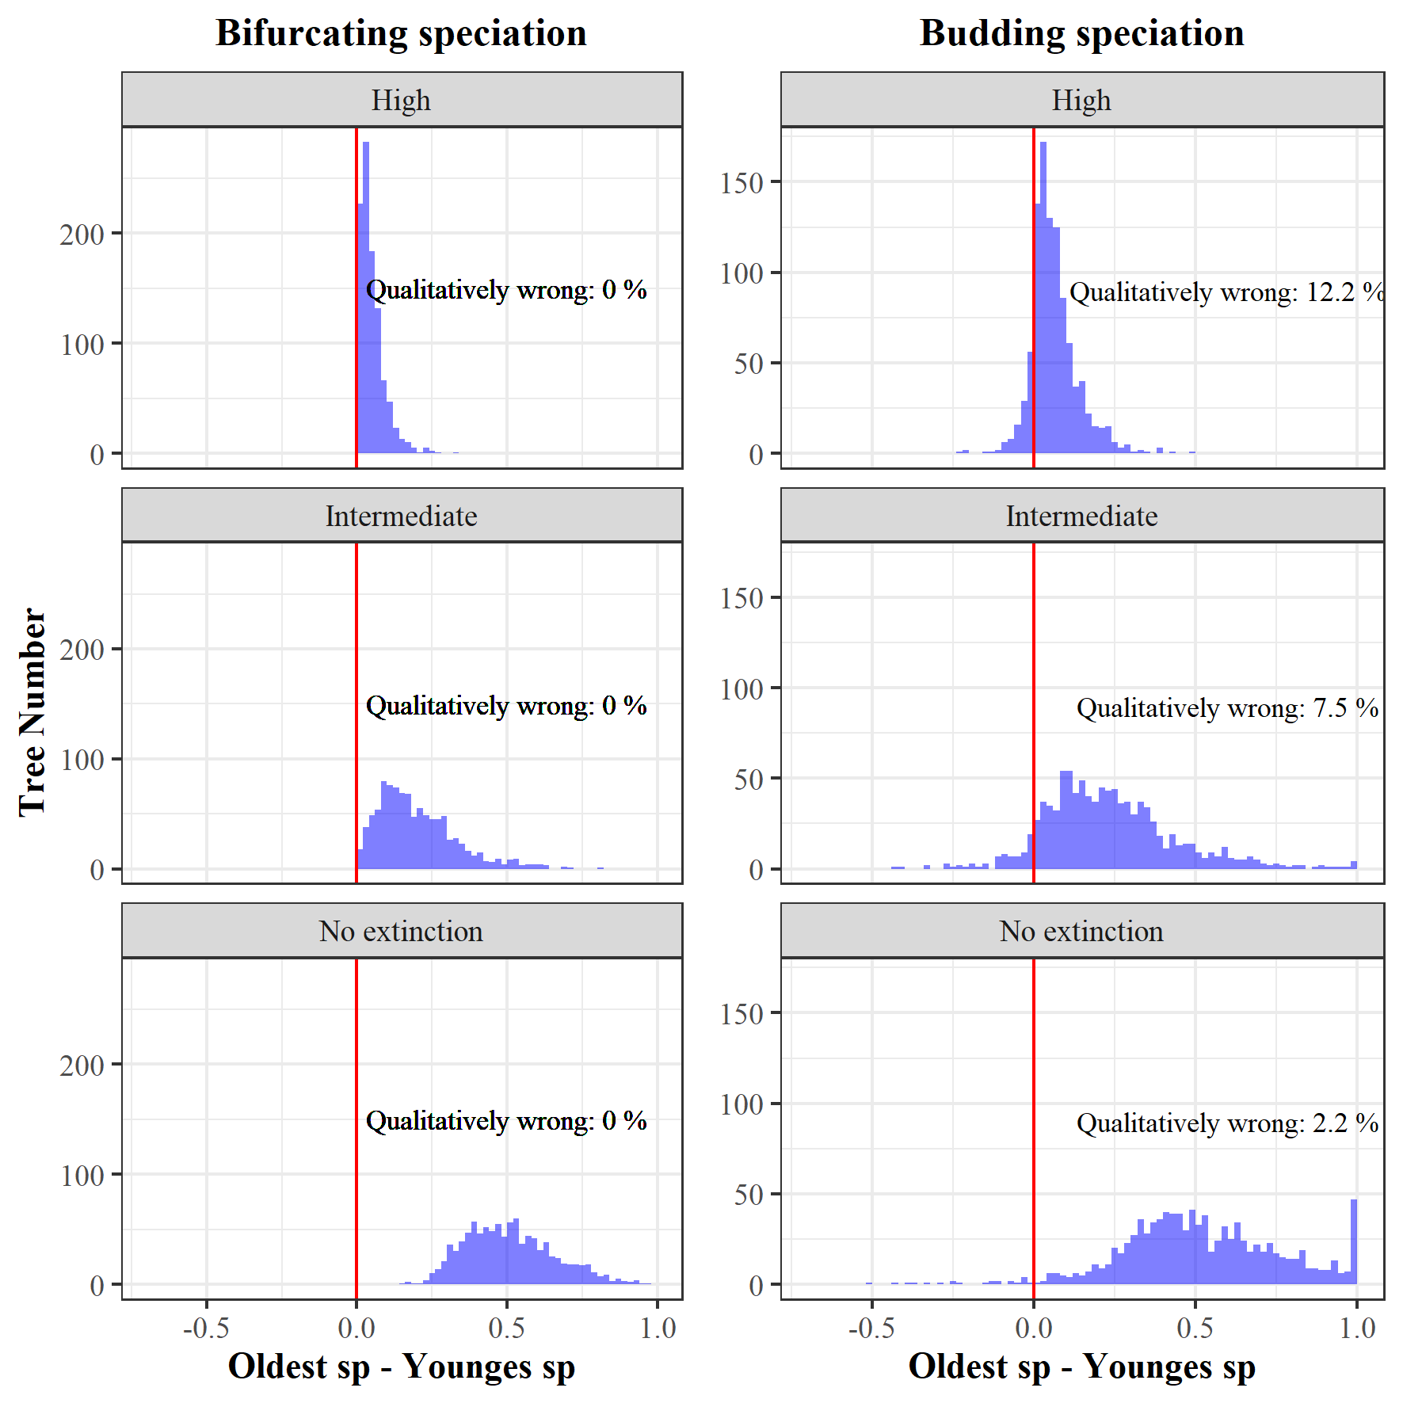

9. Risk to confuse the oldest with the youngest species. For 100 simulations under bifurcating and budding speciation, combined with three different extinction levels, we selected the, according their phylogenetic ages, oldest and youngest species and calculated the difference in their true, simulated ages. An age difference smaller than 0 indicates that the phylogenetically older species was in fact the younger species in our simulations and therefore the comparison of phylogenetic ages is qualitatively wrong.

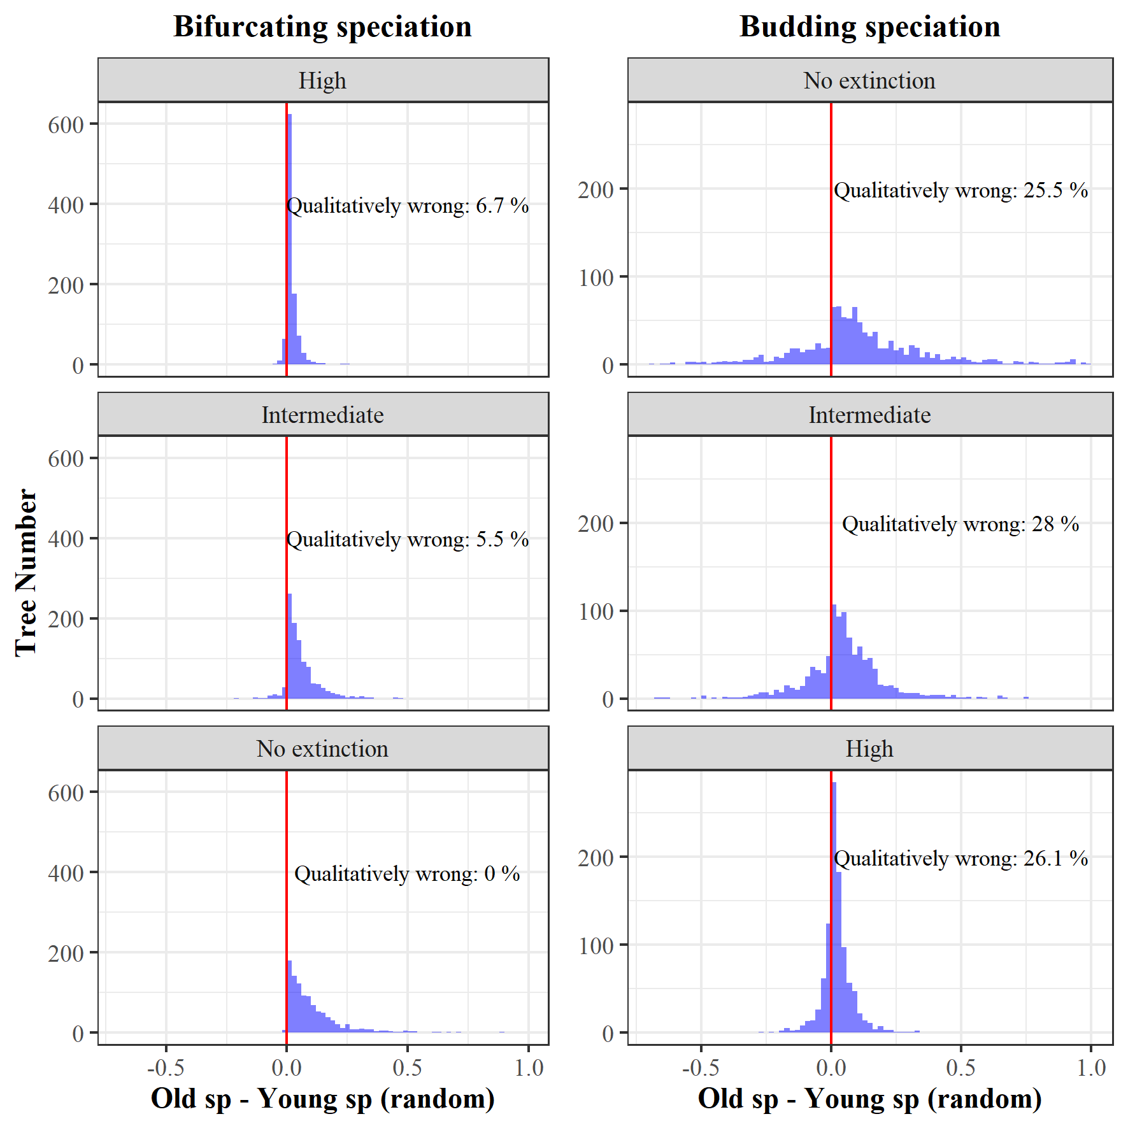

10. Old - young random species according to the phylogenetic age but using the true age (scaled); for bifurcating and budding speciation

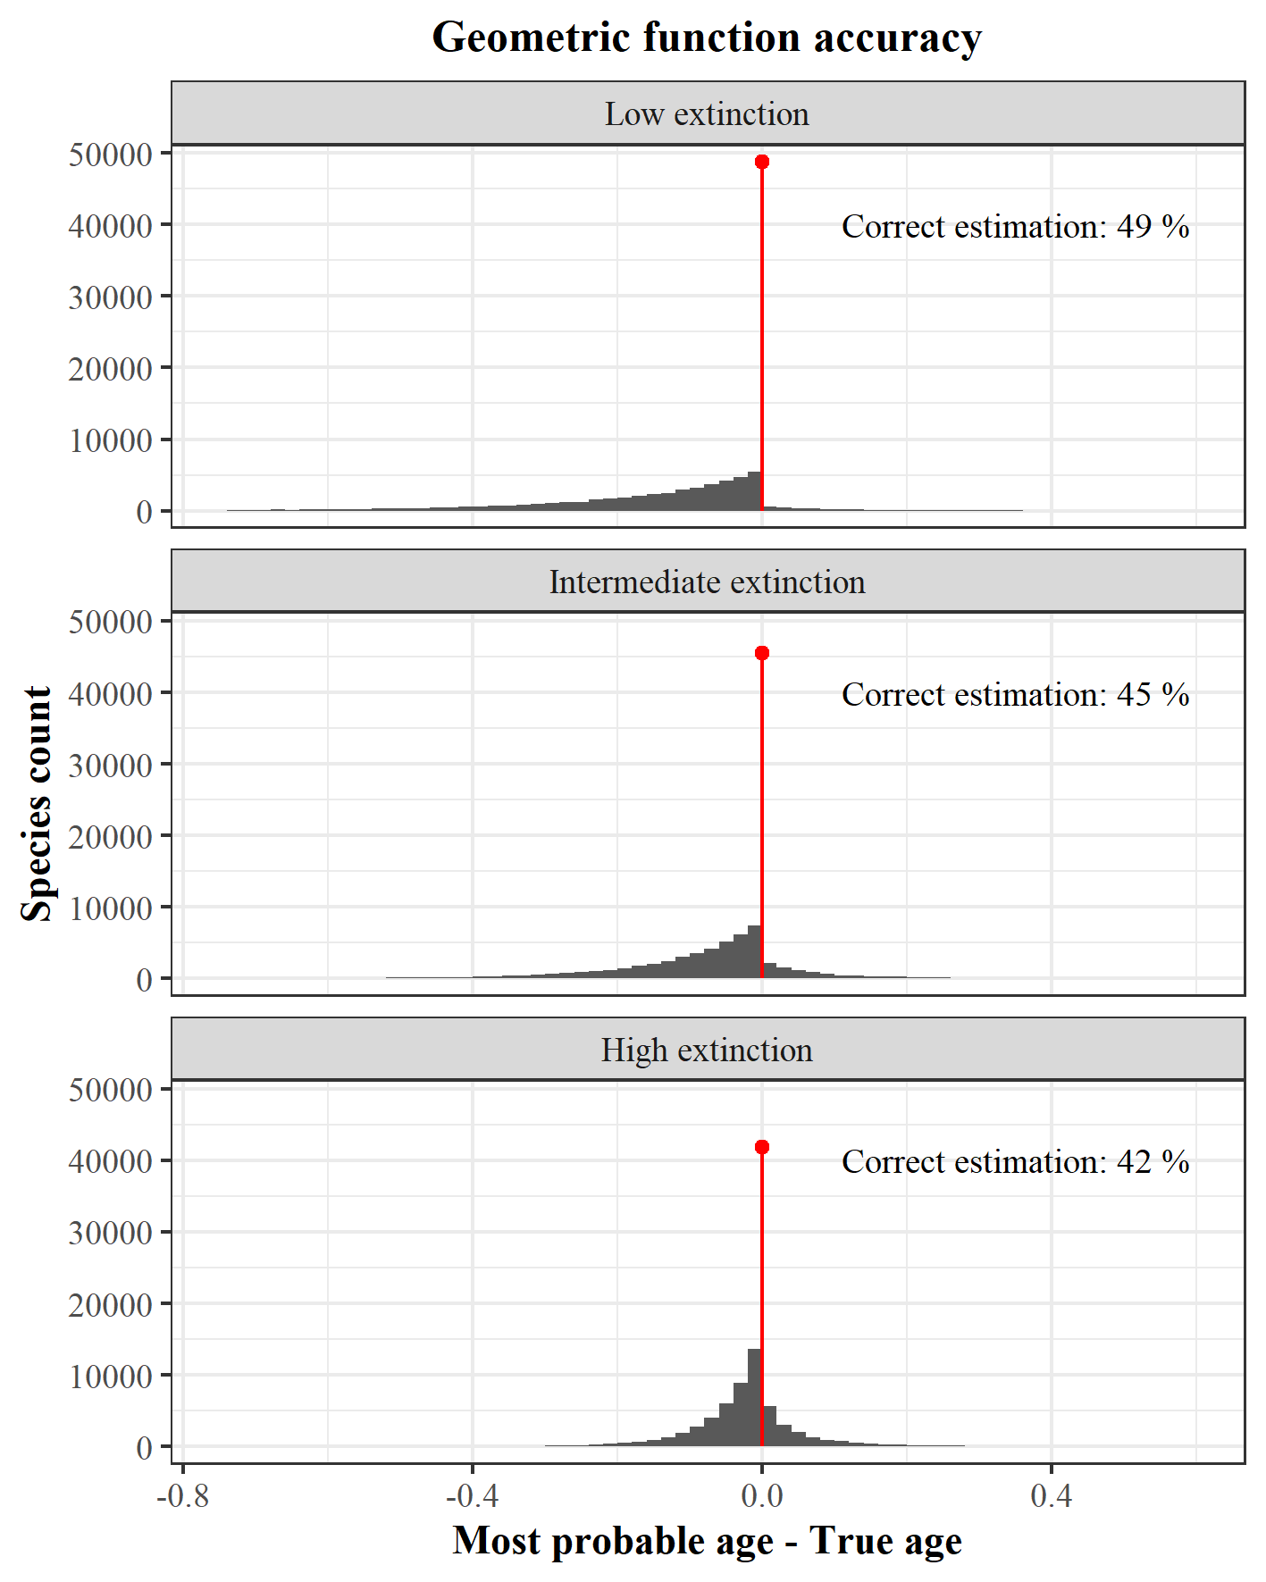

11. Geometric function accuracy regarding the Most probable age, for three extinction scenarios (Low, Intermediate, and High extinction)

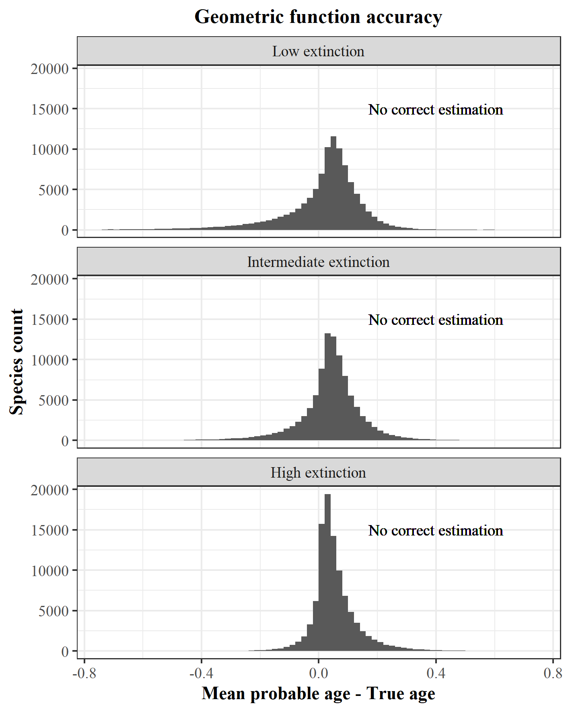

12. Geometric function accuracy regarding the Mean probable age, for three extinction scenarios (Low, Intermediate, and High extinction)

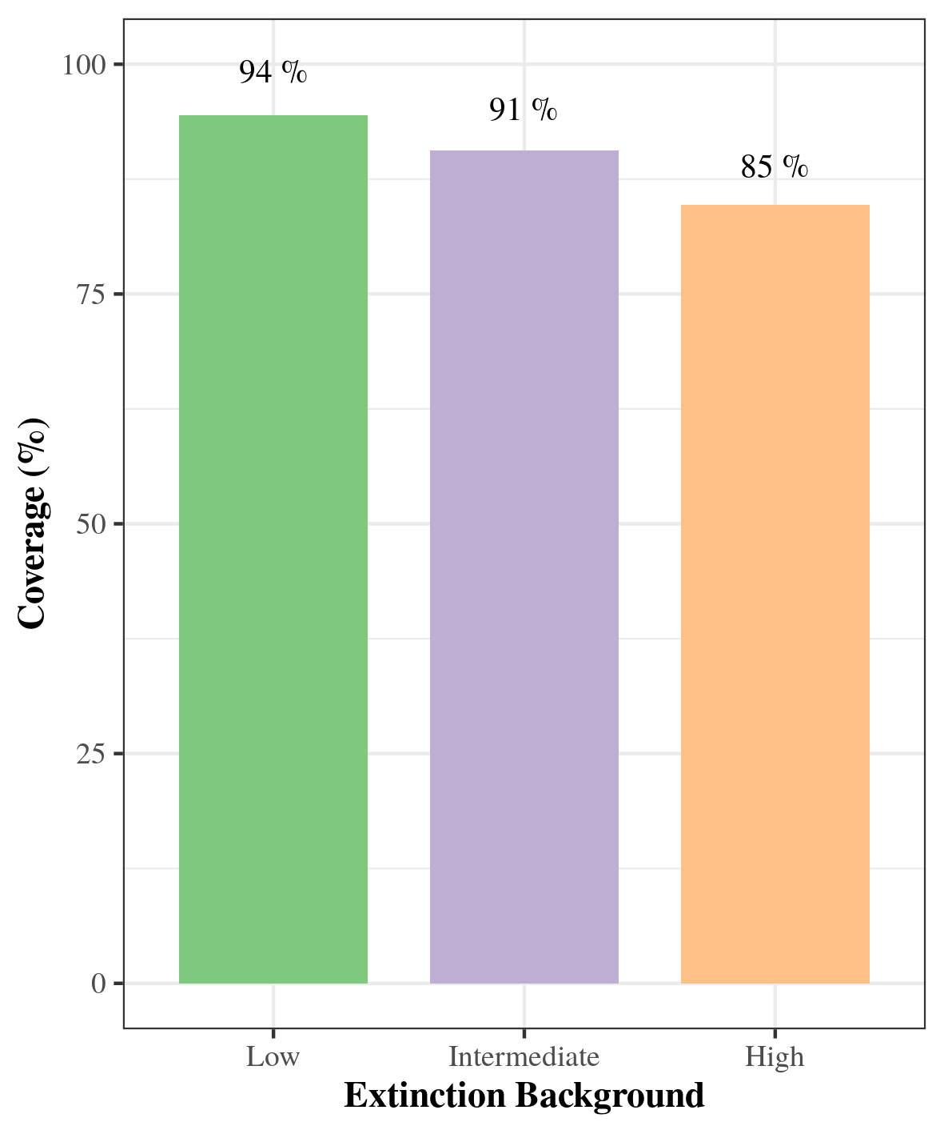

13. Geometric function coverage regarding the Confidence interval, for three extinction scenarios (Low, Intermediate, and High extinction)

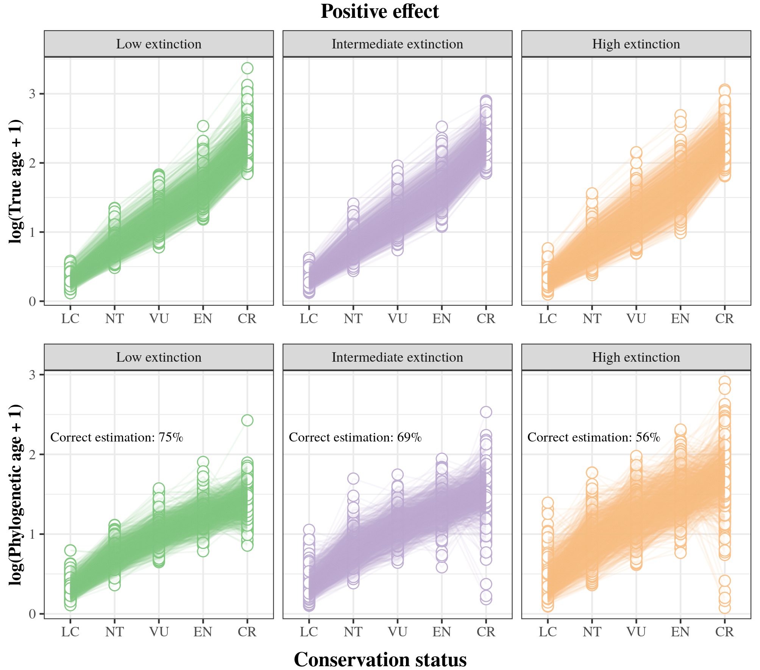

Positive Extinction signal comparison between True age and Phylogenetic age, for three extinction scenarios(Low, Intermediate, and High extinction). Extinction signal is represented by the conservation status categories (LC = Least Concern; NT = Near Threatened; VU = Vulnerable; EN = Endangered; CR = Critically Endangered)

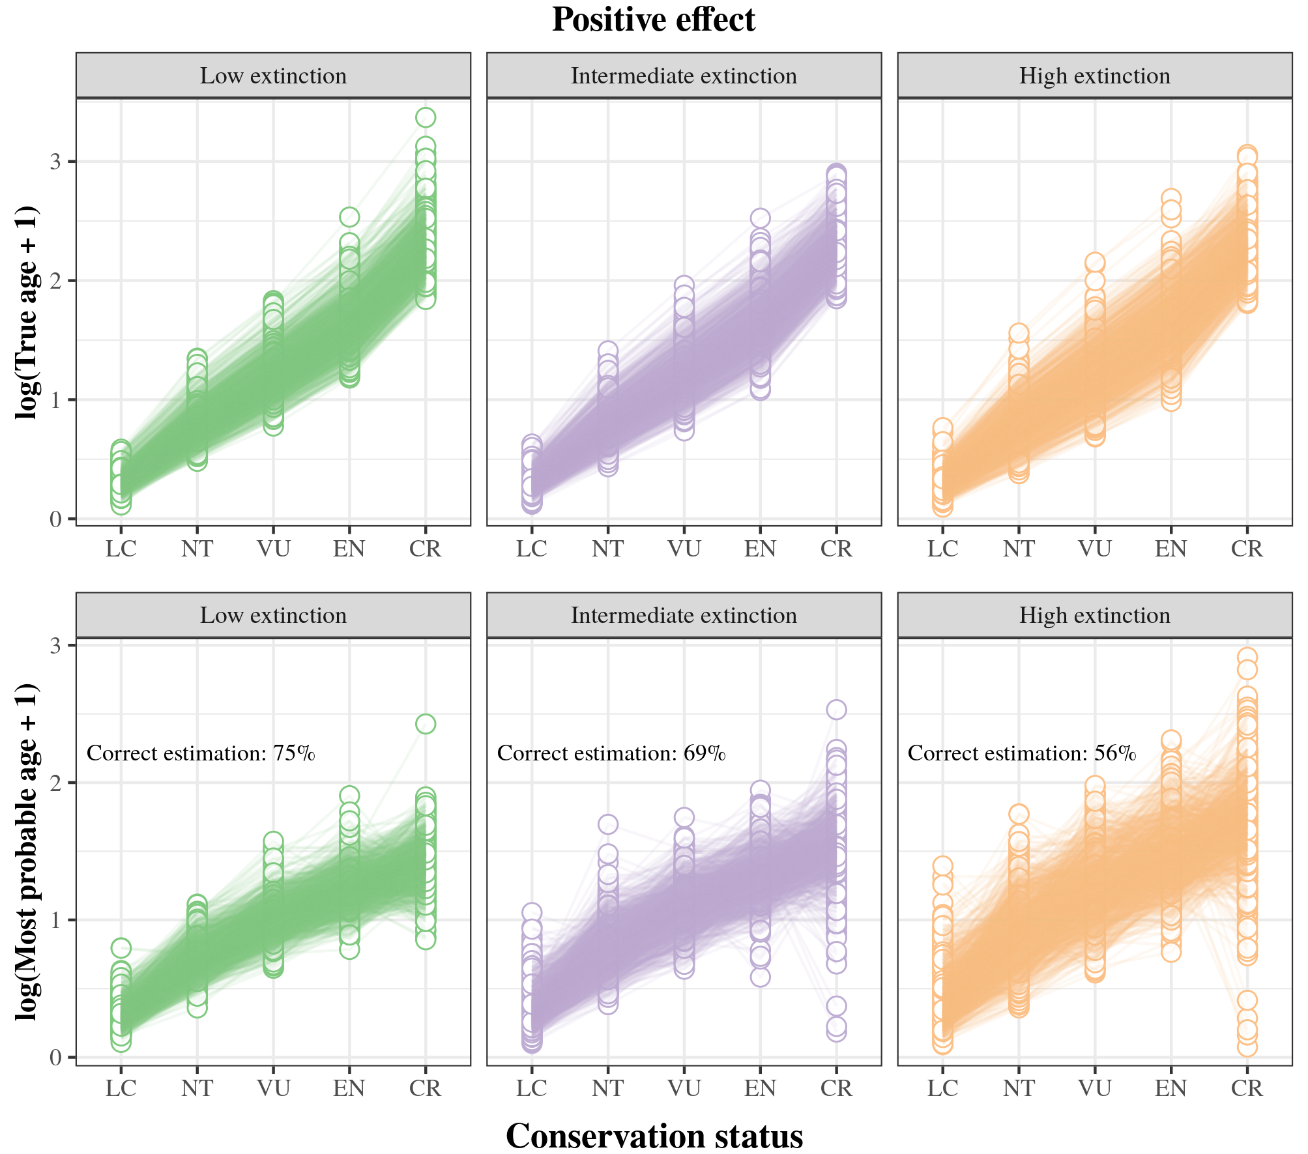

Positive Extinction signal comparison between True age and Most probable age from the geometric function, for three extinction scenarios(Low, Intermediate, and High extinction). Extinction signal is represented by the conservation status categories (LC = Least Concern; NT = Near Threatened; VU = Vulnerable; EN = Endangered; CR = Critically Endangered)

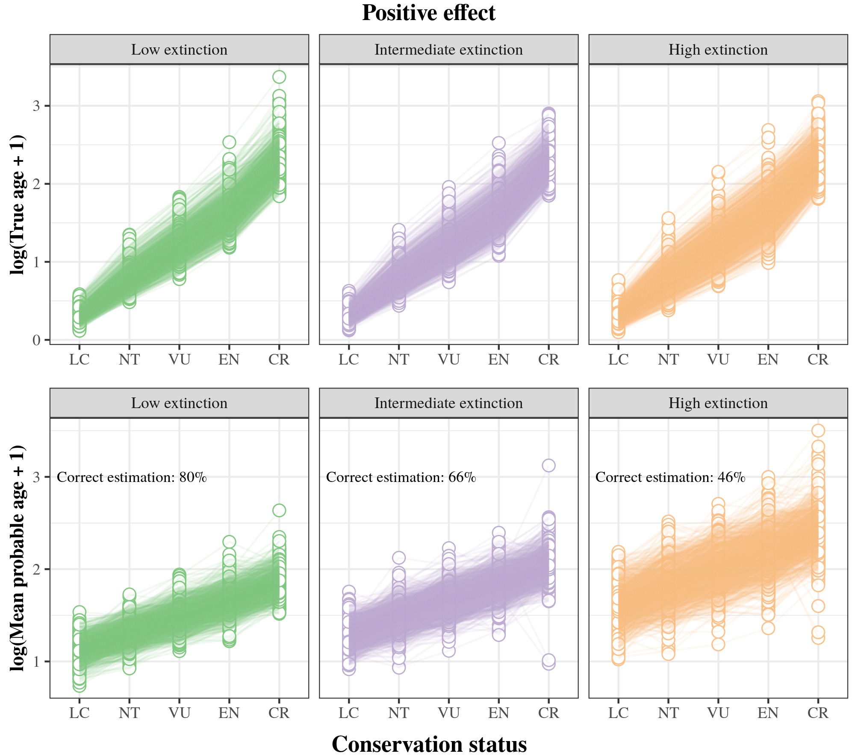

Positive Extinction signal comparison between True age and Mean probable age from the geometric function, for three extinction scenarios(Low, Intermediate, and High extinction). Extinction signal is represented by the conservation status categories (LC = Least Concern; NT = Near Threatened; VU = Vulnerable; EN = Endangered; CR = Critically Endangered)

Anacker, Brian L, and Sharon Y Strauss. 2014. “The Geography and Ecology of Plant Speciation: Range Overlap and Niche Divergence in Sister Species.” *Proceedings of the Royal Society B: Biological Sciences* 281 (1778): 20132980.

Balmford, Andrew. 1996. “Extinction Filters and Current Resilience: The Significance of Past Selection Pressures for Conservation Biology.” *Trends in Ecology & Evolution* 11 (5): 193–96.

Bapst, David W. 2012. “Paleotree: An r Package for Paleontological and Phylogenetic Analyses of Evolution.” *Methods in Ecology and Evolution* 3 (5): 803–7.

Barido-Sottani, Joëlle, Walker Pett, Joseph E O’Reilly, and Rachel CM Warnock. 2019. “FossilSim: An r Package for Simulating Fossil Occurrence Data Under Mechanistic Models of Preservation and Recovery.” *Methods in Ecology and Evolution* 10 (6): 835–40.

Barraclough, Timothy G, and Alfried P Vogler. 2000. “Detecting the Geographical Pattern of Speciation from Species-Level Phylogenies.” *The American Naturalist* 155 (4): 419–34.

Barraclough, Timothy G, Alfried P Vogler, and Paul H Harvey. 1998. “Revealing the Factors That Promote Speciation.” *Philosophical Transactions of the Royal Society of London. Series B: Biological Sciences* 353 (1366): 241–49.

Baum, David A, Stacey DeWitt Smith, and Samuel SS Donovan. 2005. “The Tree-Thinking Challenge.” *Science* 310 (5750): 979–80.

Benton, Michael J. 2016. “Origins of Biodiversity.” *PLoS Biology* 14 (11): e2000724.

Brée, Baptiste, Fabien L. Condamine, and Guillaume Guinot. 2022. “Combining Palaeontological and Neontological Data Shows a Delayed Diversification Burst of Carcharhiniform Sharks Likely Mediated by Environmental Change.” *Scientific Reports* 12 (1): 21906. <https://doi.org/10.1038/s41598-022-26010-7>.

Caetano, Daniel S, and Tiago B Quental. 2022. “How Important Is Budding Speciation for Comparative Studies?” *bioRxiv*.

Cai, Lirong, Holger Kreft, Amanda Taylor, Pierre Denelle, Julian Schrader, Franz Essl, Mark van Kleunen, et al. 2022. “Global Models and Predictions of Plant Diversity Based on Advanced Machine Learning Techniques.” *New Phytologist*.

Callaway, Ewan. 2017. “Oldest Homo Sapiens Fossil Claim Rewrites Our Species’ History.” *Nature* 546: 289–93.

Carrillo, Juan D, Analı́a Forasiepi, Carlos Jaramillo, and Marcelo R Sánchez-Villagra. 2015. “Neotropical Mammal Diversity and the Great American Biotic Interchange: Spatial and Temporal Variation in South America’s Fossil Record.” *Frontiers in Genetics* 5: 451.

Conservation of Nature, International Union for, International Union for Conservation of Nature, Natural Resources. Species Survival Commission, and IUCN Species Survival Commission. 2001. *IUCN Red List Categories and Criteria*. IUCN.

Davies, T Jonathan, Gideon F Smith, Dirk U Bellstedt, James S Boatwright, Benny Bytebier, Richard M Cowling, Felix Forest, et al. 2011. “Extinction Risk and Diversification Are Linked in a Plant Biodiversity Hotspot.” *PLoS Biology* 9 (5): e1000620.

Eldredge, Niles, John N Thompson, Paul M Brakefield, Sergey Gavrilets, David Jablonski, Jeremy BC Jackson, Richard E Lenski, Bruce S Lieberman, Mark A McPeek, and William Miller. 2005. “The Dynamics of Evolutionary Stasis.” *Paleobiology* 31 (S2): 133–45.

Fitzpatrick, Benjamin M, and Michael Turelli. 2006. “The Geography of Mammalian Speciation: Mixed Signals from Phylogenies and Range Maps.” *Evolution* 60 (3): 601–15.

Fjeldså, Jon, Rauri CK Bowie, and Carsten Rahbek. 2012. “The Role of Mountain Ranges in the Diversification of Birds.” *Annual Review of Ecology, Evolution, and Systematics* 43: 249–65.

Foote, Michael, James S Crampton, Alan G Beu, Bruce A Marshall, Roger A Cooper, Phillip A Maxwell, and Iain Matcham. 2007. “Rise and Fall of Species Occupancy in Cenozoic Fossil Mollusks.” *Science* 318 (5853): 1131–34.

Foote, Mike. 1996. “On the Probability of Ancestors in the Fossil Record.” *Paleobiology* 22 (2): 141–51.

Foote, Mike, and David M Raup. 1996. “Fossil Preservation and the Stratigraphic Ranges of Taxa.” *Paleobiology* 22 (2): 121–40.

Gaston, Kevin J et al. 1997. “Evolutionary Age and Risk of Extinction in the Global Avifauna.” *Evolutionary Ecology* 11 (5): 557–65.

Hagen, Oskar, Tobias Andermann, Tiago B Quental, Alexandre Antonelli, and Daniele Silvestro. 2018. “Estimating Age-Dependent Extinction: Contrasting Evidence from Fossils and Phylogenies.” *Systematic Biology* 67 (3): 458–74.

Hagen, Oskar, Klaas Hartmann, Mike Steel, and Tanja Stadler. 2015. “Age-Dependent Speciation Can Explain the Shape of Empirical Phylogenies.” *Systematic Biology* 64 (3): 432–40.

Harmon, Luke J. 2019. *Phylogenetic Comparative Methods*. Independent.

Heath, Tracy A, Shannon M Hedtke, and David M Hillis. 2008. “Taxon Sampling and the Accuracy of Phylogenetic Analyses.” *Journal of Systematics and Evolution* 46 (3): 239–57.

Januario, Matheus, and Tiago B Quental. 2021. “Re-Evaluation of the ‘Law of Constant Extinction’ for Ruminants at Different Taxonomical Scales.” *Evolution* 75 (3): 656–71.

Johnson, Christopher N, Steven Delean, and Andrew Balmford. 2002. “Phylogeny and the Selectivity of Extinction in Australian Marsupials.” *Animal Conservation* 5 (2): 135–42.

Lee, William G, Andrew J Tanentzap, and Peter B Heenan. 2012. “Plant Radiation History Affects Community Assembly: Evidence from the New Zealand Alpine.” *Biology Letters* 8 (4): 558–61.

Leopold, Devin R, Andrew J Tanentzap, William G Lee, Peter B Heenan, and Tadashi Fukami. 2015. “Evolutionary Priority Effects in New Zealand Alpine Plants Across Environmental Gradients.” *Journal of Biogeography* 42 (4): 729–37.

López-Martı́nez, Andrea M, Jürg Schönenberger, Maria von Balthazar, César A González-Martı́nez, Santiago Ramı́rez-Barahona, Hervé Sauquet, and Susana Magallón. 2023. “Integrating Fossil Flowers into the Angiosperm Phylogeny Using Molecular and Morphological Evidence.” *Systematic Biology*, syad017.

Magallon, Susana, and Michael J Sanderson. 2001. “Absolute Diversification Rates in Angiosperm Clades.” *Evolution* 55 (9): 1762–80.

Mann, Alan, and Mark Weiss. 1996. “Hominoid Phylogeny and Taxonomy: A Consideration of the Molecular and Fossil Evidence in an Historical Perspective.” *Molecular Phylogenetics and Evolution* 5 (1): 169–81.

Marshall, Charles R. 2017. “Five Palaeobiological Laws Needed to Understand the Evolution of the Living Biota.” *Nature Ecology & Evolution* 1 (6): 1–6.

McGill, Brian J, Jonathan M Chase, Joaquı́n Hortal, Isaac Overcast, Andrew J Rominger, James Rosindell, Paulo AV Borges, et al. 2019. “Unifying Macroecology and Macroevolution to Answer Fundamental Questions about Biodiversity.” *Global Ecology and Biogeography* 28 (12): 1925–36.

Meier, Rudolf, and Rainer Willmann. 2000. “A Defense of the Hennigian Species Concept.” *Species Concepts and Phylogenetic Theory*, 167.

Mynard, Poppy, Adam Algar, Lesley Lancaster, Greta Bocedi, Fahri Fahri, Cécile Gubry-Rangin, Pungki Lupiyaningdyah, et al. 2023. “Impact of Phylogenetic Tree Completeness and Misspecification of Sampling Fractions on Trait Dependent Diversification Models.” *Systematic Biology*.

Pearson, Paul N. 1995. “Investigating Age-Dependency of Species Extinction Rates Using Dynamic Survivorship Analysis.” *Historical Biology* 10 (2): 119–36.

Poisot, Timothée, James D Bever, Adnane Nemri, Peter H Thrall, and Michael E Hochberg. 2011. “A Conceptual Framework for the Evolution of Ecological Specialisation.” *Ecology Letters* 14 (9): 841–51.

Rabosky, Daniel L. 2010. “Extinction Rates Should Not Be Estimated from Molecular Phylogenies.” *Evolution: International Journal of Organic Evolution* 64 (6): 1816–24.

Raup, David M. 1985. “Mathematical Models of Cladogenesis.” *Paleobiology* 11 (1): 42–52.

Rosenblum, Erica Bree, Brice AJ Sarver, Joseph W Brown, Simone Des Roches, Kayla M Hardwick, Tyler D Hether, Jonathan M Eastman, Matthew W Pennell, and Luke J Harmon. 2012. “Goldilocks Meets Santa Rosalia: An Ephemeral Speciation Model Explains Patterns of Diversification Across Time Scales.” *Evolutionary Biology* 39: 255–61.

Silvestro, Daniele, Silvia Castiglione, Alessandro Mondanaro, Carmela Serio, Marina Melchionna, Paolo Piras, Mirko Di Febbraro, Francesco Carotenuto, Lorenzo Rook, and Pasquale Raia. 2020. “A 450 Million Years Long Latitudinal Gradient in Age-Dependent Extinction.” *Ecology Letters* 23 (3): 439–46.

Silvestro, Daniele, Nicolas Salamin, Alexandre Antonelli, and Xavier Meyer. 2019. “Improved Estimation of Macroevolutionary Rates from Fossil Data Using a Bayesian Framework.” *Paleobiology* 45 (4): 546–70.

Silvestro, Daniele, Nicolas Salamin, and Jan Schnitzler. 2014. “PyRate: A New Program to Estimate Speciation and Extinction Rates from Incomplete Fossil Data.” *Methods in Ecology and Evolution* 5 (10): 1126–31.

Silvestro, Daniele, Rachel Warnock, Alexandra Gavryushkina, and Tanja Stadler. 2018. “Closing the Gap Between Palaeontological and Neontological Speciation and Extinction Rate Estimates.” *Nature Communications* 9 (1): 1–14.

Sonne, Jesper, Bo Dalsgaard, Michael K Borregaard, Jonathan Kennedy, Jon Fjeldså, and Carsten Rahbek. 2022. “Biodiversity Cradles and Museums Segregating Within Hotspots of Endemism.” *Proceedings of the Royal Society B* 289 (1981): 20221102.

Stadler, Tanja. 2011. “Simulating Trees with a Fixed Number of Extant Species.” *Systematic Biology* 60 (5): 676–84.

Stadler, Tanja, Alexandra Gavryushkina, Rachel CM Warnock, Alexei J Drummond, and Tracy A Heath. 2018. “The Fossilized Birth-Death Model for the Analysis of Stratigraphic Range Data Under Different Speciation Modes.” *Journal of Theoretical Biology* 447: 41–55.

Swenson, Nathan G. 2019. *Phylogenetic Ecology: A History, Critique, and Remodeling*. University of Chicago Press.

Tanentzap, Andrew J, Angela J Brandt, Rob D Smissen, Peter B Heenan, Tadashi Fukami, and William G Lee. 2015. “When Do Plant Radiations Influence Community Assembly? The Importance of Historical Contingency in the Race for Niche Space.” *New Phytologist* 207 (2): 468–79.

Tanentzap, Andrew J, Javier Igea, Matthew G Johnston, and Matthew J Larcombe. 2020. “Does Evolutionary History Correlate with Contemporary Extinction Risk by Influencing Range Size Dynamics?” *The American Naturalist* 195 (3): 569–76.

Van Valen, Leigh. 1973. “A New Evolutionary Law.” *Evol Theory* 1: 1–30.

Vellend, Mark. 2016. “The Theory of Ecological Communities (MPB-57).” In *The Theory of Ecological Communities (MPB-57)*. Princeton University Press.

Verde Arregoitia, Luis Darcy, Simon P Blomberg, and Diana O Fisher. 2013. “Phylogenetic Correlates of Extinction Risk in Mammals: Species in Older Lineages Are Not at Greater Risk.” *Proceedings of the Royal Society B: Biological Sciences* 280 (1765): 20131092.

Wagner, Peter J, Douglas H Erwin, and RL Anstey. 1995. “Phylogenetic Patterns as Tests of Speciation Models.” *New Approaches to Speciation in the Fossil Record. Columbia University Press, New York*, 87–122.